Skincare Brand Case Study

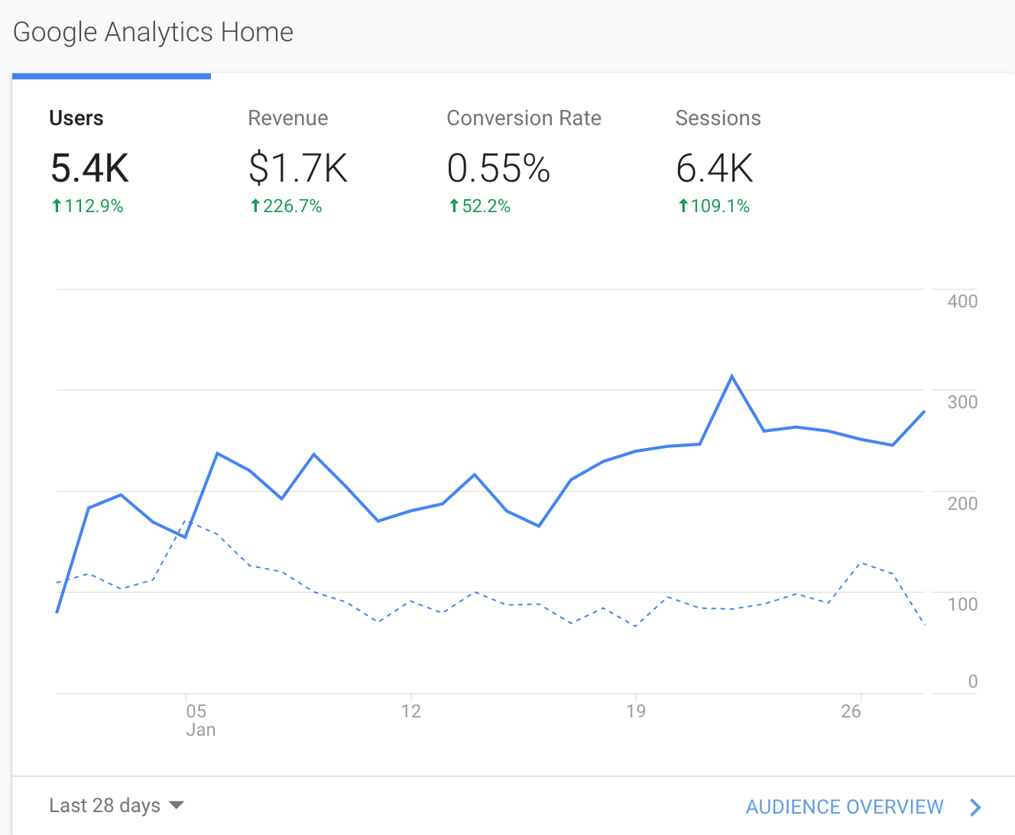

In the last 28 days, we increased revenue 226.7% and conversion rate over 52%. This came a multi-touch channel approach that involved utilizing search to bring in qualified traffic and retarget across Google, Facebook, Instagram and email.

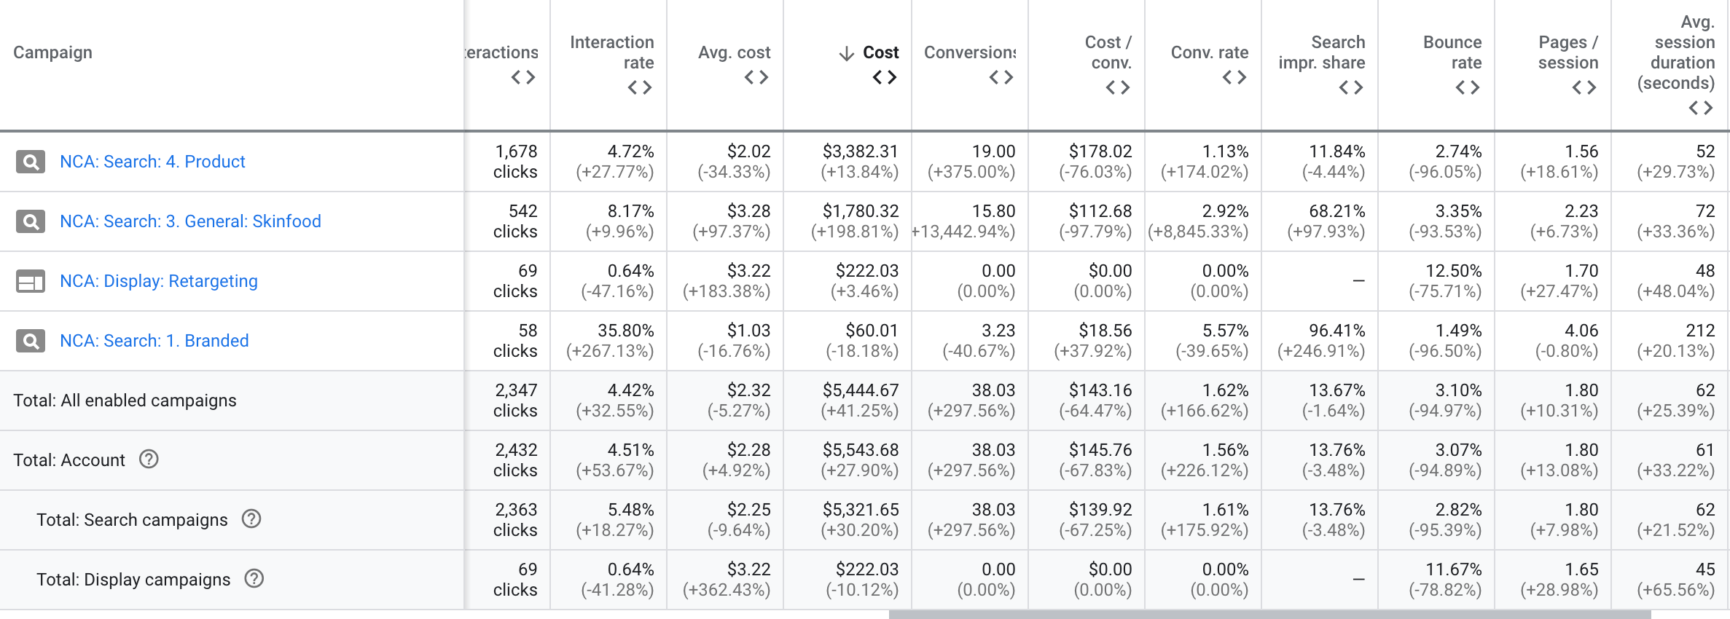

Overall in search we have three core search campaigns and one display remarketing campaign. The search campaigns while focused on maximizing for conversions to find us as many add to carts and purchases as possible, we focus on getting user’s to spend as much time on site as possible. As you can see, the average user has spent over 60 seconds on the site which gives them enough time to read the information and process it. That takes many of those user’s past the awareness stage and into the consideration stage of the buyer’s decision cycle.

The display remarketing ads are images and videos that show on popular websites such as YouTube and weather.com. These image ads are rarely clicked on but used to act as a reminder to past visitors to keep the product in mind and not forget about it. Then people search for the brand on SEO or buy through email or social media retargeting.

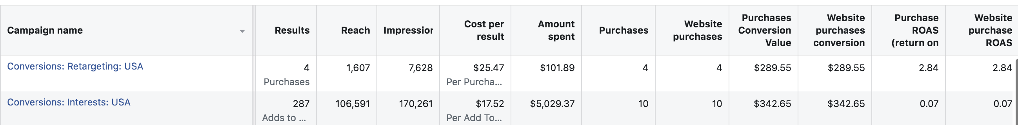

In terms of Facebook and Instagram ads we also kept the consumer decision funnel in mind. For awareness ads which are people who are not aware of the brand (including lookalike audiences) we had the algorthim optimize to find user’s to add to cart. While we did get some purchases this was not the main goal of the campaign. The main goal was to find users who are not aware of the brand and get them to the awareness/consideration phase of the decision cycle. By focusing cold traffic to add to cart instead of purchase the algorthim can find these people at a reasonable cost. When setting goals it is important to understand the likelihood of someone in your audience set completing that goal. For instance, targeting someone who has never heard of your brand to come to your website, add something to cart, initiate checkout and purchase from one touchpoint is extremely unlikely.

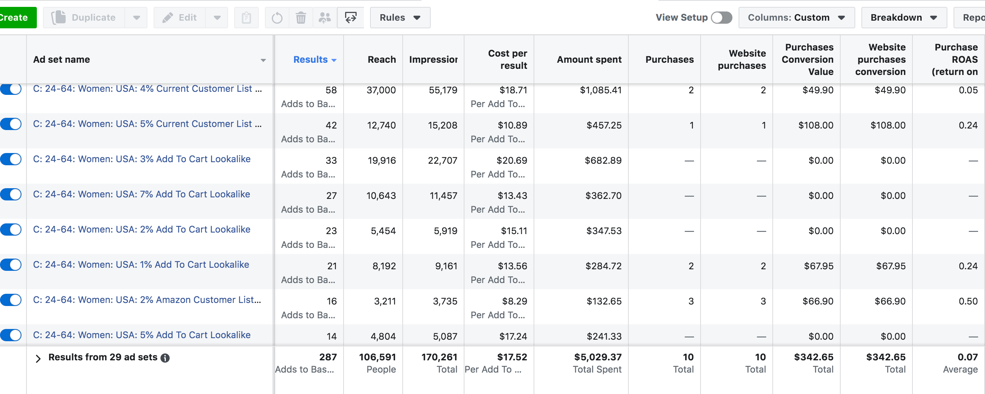

To build our audiences we used a combination of lookalike audiences. Since we had a list of Amazon customers as well past website purchasers we were able to create lookalike audiences from those lists. We started with 1% and 2% lookalikes and as we saw the lists were successful we expanded those lookalike audiences to 3%, 4% and so on. Eventually we had over 50 add to carts per week and that’s when we were able to add lookalikes for add to carts (the action we desired) again we started with 1% and 2% lookalikes for add to carts and eventually get up to ad sets that had 10% lookalikes of add to carts and find them as a reasonable cost.

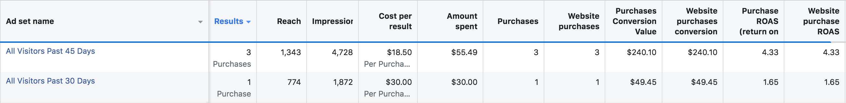

Lastly if you look at the retargeting campaign we specifically created ad sets for those who visited the website (from any channel) in the past 30 days and 45 days. As we had more data we could test past 60 days, 90 days, etc. and expand as long as the ROAS (return on investment) is above one. These people could have come through Google Ads and seen these ads and bought or through SEO and saw this retargeting ad and decided to buy. These ads also like the display remarketing ads act as a reminder to past website visitors so they may be scrolling through Instagram and see these ads then decide to buy via email or SEO.

To sum up, the path to purchase is no longer a linear one-touch, one-channel approach. You need to create ads and campaigns that drive users through the entire consumer journey from awareness to consideration to purchase. Search ads as long as they are focused to maximize for add to carts and purchases and get engaged user’s to spend at least a minute on the site will be valuable to the brand. Display ads will act as a consideration driver to past website visitors and Facebook ads for awareness ads should be optimized for add to carts and a retargeting campaign should be setup to retarget past website visitors with a goal to have a ROAS of at least 2-4.

